HR/Payroll  Data Owner Handbook  ERP Roles  Business Objects  Role Matrix  (Revised)  June 25, 2024 | 

*No information should be updated/changed in this Data Owner Handbook, or in any of the attached documents included on the last page.
Table of Contents
Data Owner Roles and Responsibilities 7
Data Owner Overview 8
Benefits Administration 8
Security Roles By Area 9
Matrix 9
Benefits 10
Display Benefits 11
Overview 11
Related Business Processes 11
Role Conflicts 11
Training 11
Organizational Management 12
Agency Position Funding Approver (Training Required) 13
Overview 13
Tasks/Responsibilities 13
Related Processes 13
Role Conflicts 13
If either or both roles are required for work, please fill out and submit SOD form 13
Role Dependencies 13
Training 13
Display Organization Management 14
Overview 14
Tasks/Responsibilities 14
Related Processes 14
Role Conflicts 14
Role Dependencies 14
Training 14
OM Position Approver (Training Required) 15
Overview 15
Tasks/Responsibilities 15
Related Processes 15
Role Conflicts 15
Role Dependencies 15
Training 15
OM Position Requestor (Training Required) 16
Overview 16
Tasks/Responsibilities 16
Related Processes 16
Role Conflicts 16
Role Dependencies 16
Training 16
Payroll Administration 17
Display Payroll 18
Overview 18
Tasks/Responsibilities 18
Related Processes 18
Role Conflicts 18
Role Dependencies 18
Training 18
Payroll Administrator 19
Overview 19
Tasks/Responsibilities 19
Related Processes 19
Role Conflicts 19
Role Dependencies 19
Payroll Administrator (continued) 20
Training 20
Personnel Administration 21
Display Non-Sensitive HR 22
Overview 22
Tasks/Responsibilities 22
Related Processes 22
Role Conflicts 22
Role Dependencies 22
Training 22
Display HR Director 23
Overview 23
Tasks/Responsibilities 23
Related Processes 23
Role Conflicts 23
Role Dependencies 23
Display HR Director (continued) 24
Training 24
Display Performance Ratings 25
Overview 25
Tasks/Responsibilities 25
Related Processes 25
Role Conflicts 25
Role Dependencies 25
Training 25
Display Salary & Pay Grade 26
Tasks/Responsibilities 26
Related Processes 26
Role Conflicts 26
Role Dependencies 26
Training 26
Display EEO 27
Overview 27
Tasks/Responsibilities 27
Related Processes 27
Role Conflicts 27
Role Dependencies 27
Training 27
Grievance Maintainer 28
Overview 28
Tasks/Responsibilities 28
Related Processes 28
Role Conflicts 28
Role Dependencies 28
Training 28
Display Grievances 29
Overview 29
Task and Responsibilities 29
Related Processes 29
Role Conflicts 29
Role Dependencies 29
Training 29
HR Master Data Approver (Training Required) 30
Overview 30
Tasks/Responsibilities 30
Related Processes 30
Role Conflicts 30
HR Master Data Approver (continued) 31
Role Dependencies 31
Training 31
HR Master Data Maintainer (Training Required) 32
Overview 32
Tasks/Responsibilities 32
Related Processes 32
Role Conflicts 32
HR Master Data Maintainer (continued) 33
Role Dependencies 33
Training 33
Short-Term Disability Specialist 34
Overview 34
Tasks/Responsibilities 34
Related Processes 34
Role Conflicts 34
Role Dependencies 34
Short-Term Disability Specialist (continued) 35
Training 35
Warnings Maintainer 36
Overview 36
Tasks/Responsibilities 36
Related Processes 36
Role Conflicts 36
Role Dependencies 36
Training 36
Display Warnings 37
Overview 37
Tasks/Responsibilities 37
Role Conflicts 37
Role Dependencies 37
Training 37
Time Administration 38
Charge Object Maintainer 39
Overview 39
Tasks/Responsibilities 39
Related Processes 39
Role Conflicts 39
Role Dependencies 39
Training 39
Display Time 40
Overview 40
Tasks/Responsibilities 40
Related Processes 40
Role Conflicts 40
Role Dependencies 40
Training 40
FMLA Event Maintainer 41
Tasks/Responsibilities 41
Related Processes 41
Role Conflicts 41
Role Dependencies 41
Training 41
Leave Administration 42
Tasks/Responsibilities 42
Related Processes 42
Role Conflicts 42
Role Dependencies 42
Leave Administration (continued) 43
Training 43
Time Administrator (Training Required) 44
Overview 44
Tasks/Responsibilities 44
Related Processes 44
Role Conflicts 44
Role Dependencies 44
Training 44
Time Approver 45
Overview 45
Tasks/Responsibilities 45
Related Processes 45
Role Conflicts 45
Role Dependencies 45
Training 45
Segregation of Duties (SOD) 46
Defining Segregation of Duties (SOD) 47
SOD (Separation of Duties) Risk Acceptance Form 48
Security Role Assignment Report -ZSECROLE 50
ZSECROLE: Overview 51
ZSECROLE: Initial Screen 51
ZSECROLE: Selection screen input options 52
ZSECROLE: Executing the report 52
ZSECROLE: Result screen 53
ZSECROLE: Report Result Details 53
Background Execution of ZSECROLE: 54
Security Role Assignment Report Tips 54
Security Change Request Procedures with Roles Requiring Training 55
Security Change Request 55
Procedures for viewing the security change request 58
Copy Security Roles from Another Position 59
Creating a Security Request 60
Managing Mass Change - Process 66
Exceptions to Normal Role Assignment Process 67
Appendix 68
ERP Role Assign Matrix 68
BOBJ Report Description and Matrix 68
Key ERP Roles and Infotype Chart 68
Copy Of SOD Form 68
Process Flow 68
Copy Of HR Exception Request Form 68

Data Owner Roles and Responsibilities

Data Owner Overview
- Data Owners are appointed by their agency.
- Data Owners are responsible to approve changes or additions to role to position/user mappings.
- The Data Owner will be the point person to approve changes for access.
- Data Owners with the correct security access will be able to create and submit security change requests.
- An existing Data Owner will need to follow the Create and Submit Security Change Request process to have the correct Security Role assigned to the new Data Owner.
- An existing Data Owner will need to be the current Data Owner for the requesting Agency.
- An existing Data Owner can remove themselves from being a data owner and add another employee as a Data Owner.
- An employee that is not a Data Owner cannot send in a request to add or remove a person from being a Data Owner.

Best practice is to have a backup Data Owner for your Agency!!

Benefits Administration

Security Roles By Area

Matrix

Benefits

Display Benefits

Overview
The role allows the user to generate reports that are related to benefit selection and ongoing administration. This role can view benefit-related information but does not have the ability to update employees’ benefit information. The employee assigned to this role should be someone that communicates benefit enrollment schedules.

Related Business Processes
- Benefits Enrollment – NC Flex, SHP, EOI, New Hire/Reinstatement
- HR Initiated Benefit Changes – Termination (LOA and non-LOA), Retirement
- Non-SAP Benefits – Savings Plans and Supplemental Benefits
- Employee Initiated Benefit Changes – Life Change Events

Role Conflicts
Those assigned this role should not be assigned the following roles to prevent conflicts of interests and to allow for segregation of duties:
- N/A

Training
Recommended training:
- BN200 Benefit Display and Reporting

Organizational Management

Agency Position Funding Approver (Training Required)

Overview
The role allows the user to approve position actions involving changes to position salary (creation of new positions and salary adjustments). This role conducts actions that are like the budget approval function formerly performed in PMIS by the agency Salary Control Officer.

Tasks/Responsibilities
- Maintain position salary amounts and cost distribution data.

Related Processes
- Create or Edit Position

Role Conflicts
Those assigned this role should not be assigned the following roles to prevent conflicts of interests and to allow for segregation of duties:
- HR Master Data Maintainer
- HR Master Data Approver

If either or both roles are required for work, please fill out and submit SOD form

Role Dependencies
Those assigned this role will also be assigned the following roles:
- Display Organization Management
- Display Salary & Pay Grade
- Display Non-Sensitive HR
- Workflow Role (FA1 – Funding Approver)
- Funding Approver BOBJ reports

Training
Required training:
- OM200 Organizational Management Overview
- WF225 Funding Approval

Display Organization Management

Overview
This role allows the user to display the organization structure, positions, and jobs within the organization; along with the employees that have been assigned to the positions.

Tasks/Responsibilities
- View job classification reports.
- View organizational management reports, including organizational structure.
- View position reports, including employees who have been assigned to positions.

Related Processes
- Create or Edit Position
- Create and Maintain Organizational Unit

Role Conflicts
Employees assigned this role should not be assigned the following roles due to segregation of duties conflicts. If any of the below roles are required to perform business duties, please follow the Segregation of Duties Approval Process:
- N/A

Role Dependencies
Those assigned this role will also be assigned the following roles:
- Agency Org. Charting Roles

Training
Recommended training:
- OM200 Organization Management Overview

OM Position Approver (Training Required)

Overview
This role allows the user to approve the creation of a new position or changes to an existing position for an organization.

Tasks/Responsibilities
- Approve the creation of a new position or changes to an existing position.

Related Processes
- Create or Edit Position
- Create and Maintain Organizational Unit

Role Conflicts
Employees assigned this role should not be assigned the following roles due to segregation of duties conflicts. If any of the below roles are required to perform business duties, please follow the Segregation of Duties Approval Process:
- N/A

Role Dependencies
Those assigned this role will also be assigned the following roles:
- Display Organization Management
- Workflow Role (AA1 - Agency or DA1 Division)
- OM BOBJ Reports
- Funding Approver BOBJ reports

Training
Required training:
- OM200 Organization Management Overview
- WF220 SAP Workflow for Approvers

OM Position Requestor (Training Required)

Overview
This role allows the user to create new positions and make changes to existing positions for an organization.

Tasks/Responsibilities
- Identify a work area or business function within an agency.
- Identify positions related to a business function within an agency.
- Request creation of a new position or changes to an existing position within an agency.

Related Processes
- Create / Edit Job
- Create and Maintain Organizational Unit

Role Conflicts
Those assigned this role should not be assigned the following roles to prevent conflicts of interests and to allow for segregation of duties:
- N/A

Role Dependencies
Those assigned this role will also be assigned the following roles:
- Display Organization Management
- Workflow Role (AA1/DA1 are not assigned)
- OM BOBJ reports

Training
Required training:
- OM200 Organization Management Overview
- OM210 Organizational Management for Agencies

Payroll Administration

Display Payroll

Overview
This role allows the user to display payroll results, W-4 withholding, payroll journal and payday calendar.

Tasks/Responsibilities
- Display pay dates.
- Display payroll results.
- Print pay advices as required.
- View general tax information.
- View non-sensitive HR data.
- View payroll journals.
- View payroll statistics.
- View time data.
- View W-4 information.

Related Processes
- N/A

Role Conflicts
Those assigned to this role should not be assigned the following roles to prevent conflicts of interests and to allow for segregation of duties:
- N/A

Role Dependencies
Those assigned this role will also be assigned the following roles:
- Payroll BOBJ Reports

Training
Recommended training:
- PY200 Payroll Overview
- PY300 Payroll Administration

Payroll Administrator

Overview
This role allows the user to maintain payroll master data for employee records, including deductions and earnings wage types. This role also acts as a liaison between agency employees and BEST Shared Services.

Tasks/Responsibilities
- Adjusts payroll for use of State vehicles.
- Collect overpayments from non-active employees.
- Communicate with employees regarding payroll issues.
- Enter cell phone supplement data for cell phone reimbursement.
- Forward off-cycle check replacement documentation to BEST Shared Services.
- Process agency-specific deductions.
- Review payroll-related reports and time data reports.
- Submit off-cycle adjustment documentation to BEST Shared Services.

Related Processes
- Paying the National Guard
- Payroll Processing / Deductions Processing
- Off Cycle Processes
- Agency-Specific Deductions & Supplements
- Relocation Pay
- Review and Resolve Time Related Issues
- Process Dual Employment

Role Conflicts
Those assigned this role should not be assigned the following roles to prevent conflicts of interests and to allow for segregation of duties:
- HR Master Data Maintainer
If either or both roles are required for work, please fill out and submit SOD form

Role Dependencies
Those assigned this role will also be assigned the following roles:
- Display Payroll
- Display Benefits
- Display Time
- Display Non-Sensitive HR
- Payroll BOBJ Reports

Payroll Administrator (continued)

Training
Required training:
- PY200 Payroll Overview
- PY300 Payroll Administration

Personnel Administration

Display Non-Sensitive HR

Overview
This role allows the user to display and report on non-sensitive employee data, including organization assignment, work address/phone, and anniversary date.

Tasks/Responsibilities
- View and generate compliance reports.
- View and generate reports on agency employee list.
- View and generate reports on default pay scales.
- View and generate reports on employee length of service and service anniversary date.
- View and generate reports on employee organizational assignment.
- View and generate reports on organizational statistics.
- View employee certifications and licenses.
- View employee telephone numbers and email.

Related Processes
- Personnel Administration Actions

Role Conflicts
Those assigned this role should not be assigned the following roles to prevent conflicts of interests and to allow for segregation of duties:
- N/A

Role Dependencies
Those assigned this role will also be assigned the following roles:
- N/A

Training
Recommended training:
- PA210 PA Terms, Concepts and Display Data

Display HR Director

Overview
The Display HR Director role can display and generate reports on HR data associated with personnel administration actions. The Display HR Director role also allows for viewing and report generation of sensitive employee data, including age, gender, ethnicity, years of service, salary, pay grade, disability, performance ratings, and employee competency levels. This role is designed for agency HR Directors (and associated pertinent staff) only.

Tasks/Responsibilities
- View and generate reports on HR data associated with personnel administration actions.
- View and generate reports on sensitive employee data, including age, gender and ethnicity.
- View and generate reports on such employment data as employee years of service, salary, pay grade, disability, performance ratings and competency levels.

Related Processes
- Personnel Administration Actions

Role Conflicts
Those assigned this role should not be assigned the following roles to prevent conflicts of interests and to allow for segregation of duties:
- N/A

Role Dependencies
Those assigned this role will also be assigned the following roles:
- Display EEO
- Display Time
- Display Benefits
- Display Organization Management
- Display Non-Sensitive HR
- HR Display BOBJ Reports

Display HR Director (continued)

Training
Recommended training:
- PA210 PA Terms, Concepts and Display Data

Display Performance Ratings

Overview
This role allows the user to display and generate reports on employee performance ratings in SAP.

Tasks/Responsibilities
- View and generate reports on employee performance rating information.

Related Processes
- Personnel Administration Actions

Role Conflicts
Those assigned this role should not be assigned the following roles to prevent conflicts of interests and to allow for segregation of duties:
- N/A

Role Dependencies
Those assigned this role will also be assigned the following roles:
- Performance Display BOBJ reports

Training
Recommended training:
- PA210 PA Terms, Concepts and Display Data

Display Salary & Pay Grade

Overview
This role allows the user to display and generate reports on employee salary and pay grade information.

Tasks/Responsibilities
- View and generate reports on employee salary and pay grade information.

Related Processes
- Personnel Administration Actions

Role Conflicts
Those assigned this role should not be assigned the following roles to prevent conflicts of interests and to allow for segregation of duties:
- N/A

Role Dependencies
Those assigned this role will also be assigned the following roles:
- N/A

Training
Recommended training:
- PA210 PA Terms, Concepts and Display Data

Display EEO

Overview
This role allows the user to display and generate reports on disability information, as well as on age, gender, ethnicity, and years of service. This role is designed for agency EEO officers.

Tasks/Responsibilities
- View and generate reports on EEO information.

Related Processes
- Personnel Administration Actions

Role Conflicts
Those assigned this role should not be assigned the following roles to prevent conflicts of interests and to allow for segregation of duties:
- N/A

Role Dependencies
Those assigned this role will also be assigned the following roles:
- EEO BOBJ Reports

Training
Recommended training:
- PA210 PA Terms, Concepts and Display Data

Grievance Maintainer

Overview
This role allows the user to maintain grievances on employee master records.

Tasks/Responsibilities
- Create a record if a grievance.
- Maintain grievances on master records.
- Monitor grievance timeframes and process.
- View and generate reports on grievance information.

Related Processes
- Personnel Administration Actions

Role Conflicts
Those assigned this role should not be assigned the following roles to prevent conflicts of interests and to allow for segregation of duties:
- N/A

Role Dependencies
Those assigned this role will also be assigned the following roles:
- Display Non-Sensitive HR
- Display Grievances
- Grievance BOBJ Reports

Training
Required training:
- PA210 PA Terms, Concepts and Display Data
- PA321 Create and Maintain Grievances Data

Display Grievances

Overview
The Display Grievances role is responsible for displaying and generating reports on employee grievance information in SAP.

Task and Responsibilities
- View and generate reports on employee grievance information.

Related Processes
- Personnel Administration Actions

Role Conflicts
Those assigned this role should not be assigned the following roles to prevent conflicts of interests and to allow for segregation of duties:
- N/A

Role Dependencies
Those assigned this role will also be assigned the following roles:
- Grievance BOBJ Reports

Training
Recommended training:
- PA210 PA Terms, Concepts and Display Data

HR Master Data Approver (Training Required)

Overview
This role allows the user to approve HR Master Data Maintainer actions pertaining to employees including hiring, separating, promoting, demoting, or reassignment information for employees. This role also approves reallocation, transfer, work against, longevity pay, leave of absence, and return from leave of absence information.

*Note: Holders of this role cannot maintain his or her own information using the transactions associated with this role; ESS must be used.

Tasks/Responsibilities
- Approve an employee’s appointment change within an agency.
- Approve career progressions.
- Approve data associated with personnel administration actions.
- Approve demotion action.
- Approve employee separation action (including retirement).
- Approve investigatory leave w/ pay.
- Approve leave of absence action (including workers compensation).
- Approve new hire / promotion / reinstatement/ suspension and transfer actions.
- Approve salary adjustments.

Related Processes
- Personnel Administration Actions
- Process Dual Employment

Role Conflicts
Those assigned this role should not be assigned the following roles to prevent conflicts of interests and to allow for segregation of duties:
- HR Master Data Maintainer
- Agency Position Funding Approver

If either or both roles are required for work, please fill out and submit SOD form

HR Master Data Approver (continued)

Role Dependencies
Those assigned this role will also be assigned the following roles:
- Display Non-Sensitive HR
- Display Benefits Display Time
- Display Salary & Pay Grade
- Display Organization Management
- PA BOBJ Reports

Training
Required training:
- PA210 PA Terms, Concepts and Display Data
- WF220 SAP Workflow for Approvers

HR Master Data Maintainer (Training Required)

Overview
This role allows the user to maintain employee master data and perform employee actions including hiring, separating, promoting, demoting, or reassignment information for employees. This role also maintains reallocation, transfer, work against, longevity pay, leave of absence, and return from leave of absence information within SAP.

Tasks/Responsibilities
- Change an employee’s appointment within an agency.
- Maintain data associated with personnel administration actions.
- Maintain dates for service calculations.
- Perform demotion action.
- Perform employee separation action (including retirement).
- Perform leave of absence action (including workers compensation).
- Perform new hire / promotion / reinstatement/ suspension and transfer actions.
- Perform salary adjustments.
- Record career progression.
- Record investigatory leave with pay.

Related Processes
- Personnel Administration Actions
- Process Dual Employment

Role Conflicts
Those assigned this role should not be assigned the following roles to prevent conflicts of interests and to allow for segregation of duties:
- HR Master Data Approver
- Agency Position Funding Approver
- Payroll Administration
If any of these roles are required for work, please fill out and submit SOD form

HR Master Data Maintainer (continued)

Role Dependencies
Those assigned this role will also be assigned the following roles:
- Display Non-Sensitive HR
- Display Benefits
- Display Time
- Display Salary & Pay Grade
- Display Organization Management
- Workflow role: (AA1/DA1 not assigned)
- PA Reports BOBJ

Training
Required training:
- PA309 Introduction to Create and Maintain Employee Data
- PA210 PA Terms, Concepts and Display Data
- PA310 Create and Maintain Employee Data
- PA313 Modifying Position/Employee Data and Reporting

Recommended training:
- PA420 Leave of Absence
- PA370 Short-Term Disability

Short-Term Disability Specialist

Overview
This role is for the user who receives the appropriate documentation from employees requesting short-term disability. This role also allows users to process an employee’s short-term disability request and determine the appropriate leave action. |  | .

Tasks/Responsibilities
- Determine eligibility for employee.
- Determine leave options.
- Enter time for employees on short-term disability.
- Place employee on short-term disability status.
- Review employee benefit plans.
- Review employee documentation.
- Review employee payroll deductions and salary.

Related Processes
- Personnel Administration Actions

Role Conflicts
Those assigned this role should not be assigned the following roles to prevent conflicts of interests and to allow for segregation of duties:
- N/A

Role Dependencies
Those assigned this role will also be assigned the following roles:
- FMLA Event Maintainer
- Leave Administrator
- Time Administrator
- Display Benefits
- Display Payroll
- Display Time
- Time Admin /FMLA BOBJ Reports

Short-Term Disability Specialist (continued)

Training
Required training:
- TM300 Time Administration
- TM310 Leave Administration
- PA210 PA Terms, Concepts and Display Data
- PA370 Short Term Disability

Warnings Maintainer

Overview
This role allows the user to maintain warnings on the employee record in SAP.

Tasks/Responsibilities
- Create a record of a warning.
- Maintain warnings on master records.
- View and generate reports on employee warnings information.

Related Processes
- Personnel Administration Actions

Role Conflicts
Those assigned this role should not be assigned the following roles to prevent conflicts of interests and to allow for segregation of duties:
- N/A

Role Dependencies
Those assigned this role will also be assigned the following roles:
- Display Non-Sensitive HR
- Display Warnings
- Warnings BOBJ Reports

Training
Required training:
- PA210 PA Terms, Concepts and Display Data
- PA322 Create and Maintain Disciplinary Actions

Display Warnings

Overview
This role allows the user to display and generate reports on employee warnings in SAP.

Tasks/Responsibilities
- View and generate reports on employee warnings information Related Processes.
- Personnel Administration Actions.

Role Conflicts
Those assigned this role should not be assigned the following roles to prevent conflicts of interests and to allow for segregation of duties:
- N/A

Role Dependencies
Those assigned this role will also be assigned the following roles:
- Warnings BOBJ Reports

Training
Recommended training:
- PA210 PA Terms, Concepts and Display Data

Time Administration

Charge Object Maintainer
Overview  This role allows the user to create and manage agency-specific charge objects that are available for employees to charge their time to within their agencies |  | .

Tasks/Responsibilities
- Assign charge codes.
- Create charge codes.

Related Processes
- N/A

Role Conflicts
Those assigned this role should not be assigned the following roles to prevent conflicts of interests and to allow for segregation of duties:
- N/A

Role Dependencies
Those assigned this role will also be assigned the following roles:
- N/A

Training
Required training:
- TM200 Time Management Overview
- TM330 Charge Object Maintainer

Display Time

Overview
This role allows the user to display time entered, leave, vacation, work schedules for employees.

Tasks/Responsibilities
- View absence and attendance quotas and reports.
- View employee organizational assignments.
- View FMLA events.
- View payroll status.
- View planned working time.
- View quota compensation information.
- View schedule information.
- View substitutions.
- View time accounts / approvals / reports /statements / timesheets.

Related Processes
- Management Processes

Role Conflicts
Those assigned this role should not be assigned the following roles to prevent conflicts of interests and to allow for segregation of duties:
- N/A

Role Dependencies
Those assigned this role will also be assigned the following roles:
- N/A

Training
Recommended training:
- TM200 Time Management Overview
- TM220 Introduction to Time Management
- TM300 Time Administration

FMLA Event Maintainer
This role establishes and maintains Family Medical Leave Act (FMLA) reasons. Also, generates FMLA records that are used by the Leave Administrator to assign FMLA and Family Illness Leave (FIL) reasons.

Tasks/Responsibilities
- Create FMLA events.
- Generate FMLA event records.

Related Processes
- N/A

Role Conflicts
Those assigned this role should not be assigned the following roles to prevent conflicts of interests and to allow for segregation of duties:
- N/A

Role Dependencies
Those assigned this role will also be assigned the following roles:
- Time Admin BOBJ Reports

Training
Required training:
- TM200 Time Management Overview
- TM210 Leave Administration
- TM310 Leave Administration

Leave Administration
This role allows the user to manage employee leave balances. This role can adjust absence quotas for “Advanced Sick Leave” and “Advanced Vacation Time”. It also manages Family Medical Leave Act (FMLA), Family Illness Leave (FIL), and shared leave programs. This role can also create manual adjustments to leave balances as required.

Tasks/Responsibilities
- Administer leave donations.
- Assign absences to FMLA/FIL reason.
- Associate an employee’s absences with FMLA or FIL.
- Create “Advanced Sick Leave” or “Advance Vacation Leave” quotas for employee’s use.
- Determine eligibility for employees requesting leave (FMLA, FIL, VSL).
- Review leave balances and make manual adjustments if discrepancy exists.

Related Processes
- Process FMLA or FIL Request or FIL Absences
- Process Participation in Shared Leave (Donor/Recipient)
- Management Processes
- Leave Processes and Balances
- Review and Resolve Time Related Issues

Role Conflicts
Those assigned this role should not be assigned the following roles to prevent conflicts of interests and to allow for segregation of duties:
- N/A

Role Dependencies
Those assigned this role will also be assigned the following roles:
- Display Time
- FMLA Time BOBJ Reports

Leave Administration (continued)

Training
Required training:
- TM200 Time Management Overview
- TM210 Leave Administration
- TM310 Leave Administration

Time Administrator (Training Required)

Overview
This role allows the user to enter time for employees without Employee Self Service (ESS), review time evaluation results, request configuration changes regarding SAP, and support the management of substitutions and on-calls. This role also can make corrections on timesheets that have already been approved.

Tasks/Responsibilities
- Edit/correct time and distribution information.
- Enter time and distribution for those without ESS.
- Generate a schedule change request.
- Identifies time processing errors.
- Provide time statements and reports to employees without ESS access.
- Request changes to cross application timesheets.

Related Processes
- Time entry

Role Conflicts
Those assigned this role should not be assigned the following roles to prevent conflicts of interests and to allow for segregation of duties:
- N/A

Role Dependencies
Those assigned this role will also be assigned the following roles:
- Display Time
- FMLA Time BOBJ Reports

Training
Required training:
- TM200 Time Management Overview
- TM220 Time Administration Overview
- TM300 Time Administration

Time Approver

Overview
This role allows the user to approve time for “unapproved” Employee Self-Service (ESS) time entry; in the absence of an agency supervisor/manager approving time in Manager Self-Service (MSS) to meet payroll deadline. The Time Approver role serves as a back-up for ESS time approved by designated agency managers/supervisors in MSS.

*Note: Non-ESS using agencies will not need to assign the Time Approver role.

Tasks/Responsibilities
- Generate time reports.
- Review and approve time for employees entering time in ESS.

Related Processes
- Time entry

Role Conflicts
Those assigned this role should not be assigned the following roles to prevent conflicts of interests and to allow for segregation of duties:
- N/A

Role Dependencies
Those assigned this role will also be assigned the following roles:
- Display Time
- Time Admin BOBJ Reports

Training
Required training:
- N/A
Recommended training:
- N/A

Segregation of Duties (SOD)

Defining Segregation of Duties (SOD)
Segregation of Duties is one of the key concepts of internal control and provides an appropriate level of checks and balances upon individuals performing related overlapping job functions. G.S. §143D-6 authorizes the State Controller to establish comprehensive standards, policies, and procedures to ensure a strong and effective system of internal control within State government. Pursuant to G.S. §143D-7, the management of each State agency is responsible for establishing and maintaining a proper system of internal control within his/her agency. While the Office of the State Controller strongly encourages agency management to ensure appropriate segregation of related job functions, we realize that there may be instances in which the size of the organization and limited staffing levels may make segregation of duties impractical or cost prohibitive. This internal control deviation must, however, be the exception and not be the norm.
The head of the agency, or designee, has the authority to manage segregation of duty conflicts. Authorization to deviate shall be based upon the business risk versus the cost associated with implementing the desired control. Where possible, agencies are encouraged to design compensating controls into their business processes. While not a substitute for a primary control such as proper segregation of duties, a compensating control can mitigate an organization’s business risk – thereby making a primary control deficiency more tolerable.
- When a SOD conflict arises, a SOD Risk Acceptance Form will need to be completed and signed by the Agency Head. This form is filed in the SOD Folder under the Security Team directory.
- The SOD signoff is for the Position, not the employee.
- This means that the SOD signoff is for the Position, and will not follow the employee if the employee goes to another position
- (Position Based Security)

SOD (Separation of Duties) Risk Acceptance Form
Employee Name
Position #
Position Name
PERNR # (include leading zeros)
Agency
This form is required to document that there is an actual business need for the following user to have two or more SAP security roles that cause a SOD (Segregation of Duties) conflict as marked below.
Role Conflict(s) | Code | Mark SOD Conflict
HR Master Data Maintainer with Payroll Administrator | 01
HR Master Data Approver with HR Master Data Maintainer | 02
HR Master Data Approver with Position Funding Approver | 03
HR Master Data Maintainer with Position Funding Approver | 04

Completion of this form indicates that you, as the agency approver, understand the risks associated with the above marked SOD conflicts. and that your agency has established and documented a compensating control process within your agency’s business processes.
Approver’s Signature __________________________________________________
Approver’s Printed Name ______________________________________________
Date Signed: ____________________
SOD Risk Acceptance Form Procedures:
- Please submit one form per employee.
- Send to BEST@osc.nc.gov. Please do not send directly to the HR/Payroll ERP System Security Team.
- Save the form using the following naming convention:
SOD_ [first initial] _ [last name] _[agency]_[date]. Example: SOD_j_doe_osc_070109.xls
- Removal of one or more of the SOD roles can be accomplished by having the Agency Data Owner submit a completed online SAP Security Role Change Form
- Note: During the regular Security Request Process, the HR/Payroll ERP System will perform a SOD Analysis for the user for whom the request pertains, and will inform the Data Owner, before the request is submitted, if a SOD conflict exists. The role will be flagged with code H or W. This flag will be removed once a signed SOD form is submitted and processed by the Security Team.

Segregation of Duties: Role Conflicts
- HR Master Data Maintainer with Payroll Administrator
- HR Master Data Approver with HR Master Data Maintainer
- HR Master Data Approver with Position Funding Approver
- HR Master Data Maintainer with Position Funding Approver

Security Role Assignment Report -ZSECROLE

ZSECROLE: Overview
This report can be used to review the security roles and Workflow relationships related to Positions. The report will also indicate what person(s) hold the position or if it is vacant, what Personnel Area the person(s) is/are in, and the top org unit that a role provides access to. The report also provides a more user-friendly description for each role.
Scenarios that this report would be useful for include:
- Reviewing the roles and/or Workflow relationships assigned to a specific position(s).
- Reviewing the roles and/or Workflow relationships assigned to any position in an org unit(s).
- Identifying the positions in an org unit(s) who have a specific role(s).
- Identifying the positions in an org unit(s) who have a specific combination of roles.

ZSECROLE: Initial Screen
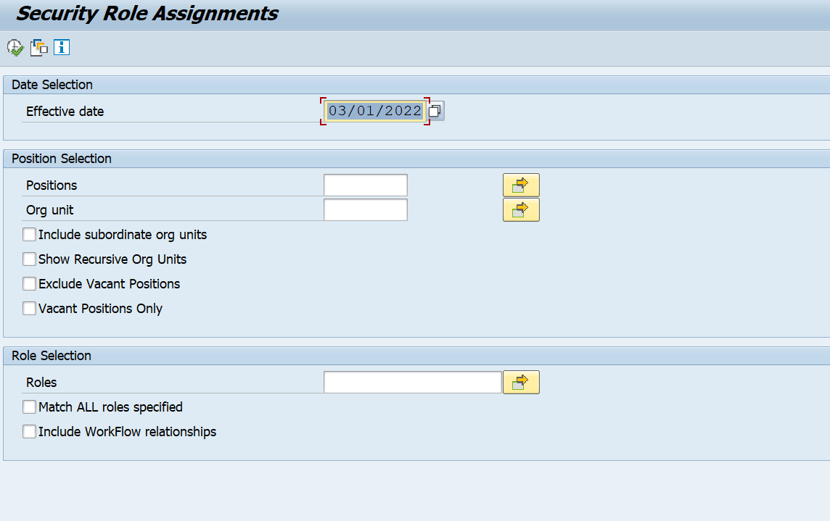

ZSECROLE: Selection screen input options
- Effective Date: The program will only return records which have a validity date range that includes the Effective Date specified. This field defaults to the current date.
- Positions: One or more Positions can be specified. If a Position is specified, you cannot specify an Org Unit. You must specify at least one Position or one Org Unit to run the report.
- Org Unit: One or more Org Units can be specified. If an Org Unit is specified, you cannot specify a Position. Roles assigned to the Positions in these Org Units on the Effective Date will be included in the report results. You must specify at least one Position or one Org Unit to run the report.
- Checkbox “Include subordinate org units”: If this box is checked the program will include all Positions in the Org Units that report to the Org Units specified.
- Checkbox “Show Recursive Org Units”: If this box is checked the program will include all recursive Org Units.
- Roles: If one or more Role names are specified, the program will only display results for those Roles.
- Checkbox “Match ALL roles specified”: If this box is checked, the program will only display results for those Positions which have ALL the Roles that have been specified.
- Checkbox “Include WorkFlow relationships”: If this box is checked, only OM/PA Approver WorkFlow relationships on the Positions specified will be included in the results.
There is a selection variant button on the initial screen. Combinations of selection criteria can be saved and easily reused by defining selection variants.
There is an Information Help button on the initial screen. Clicking this button will bring up a window containing a brief description of each of the input fields.

ZSECROLE: Executing the report
- Enter the appropriate selection criteria values.
- Click the Execute button.
- Review the results.

ZSECROLE: Result screen
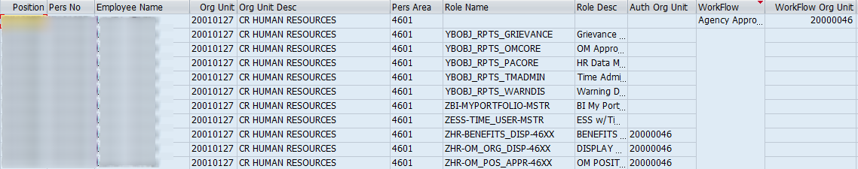

ZSECROLE: Report Result Details
Each Role assignment record or Workflow relationship record found will be represented with a separate row in the report results.
Positions with multiple Holders will be represented with a separate row in the results for each Role for each Holder.
- Position: This column contains the Position number.
- Pers No: This column contains the Personnel Number of the Holder of a Position. If no Holder exists, the word VACANT will be in the column.
- Employee Name: This column contains the name of the Holder of a Position. If no Holder exists, the word VACANT will be in the column.
- Org Unit: This column contains the Org Unit that the Position belongs to.
- Org Unit Desc: This column contains the Description of the Org Unit the Position belongs to.
- Pers Area: This column contains the Pers Area that the Holder of the Position belongs to. If the Position is vacant, this column will be empty.
- Role Name: This column contains the technical Role Name. This column will be empty for rows showing Workflow relationships.
- Role Desc: This column contains the Description of the Role. This column will be empty for rows showing Workflow relationships.
- Auth Org Unit: This column contains the highest org unit that the role has authorization for. The user will also have authorization for all org units under that one in the org unit hierarchy. This column will be empty for BOBJ and Portal role assignments, as they themselves do not contain the authorization setting. This column will be empty for rows showing Workflow relationships.
- Role Start: This column contains the Start Date of the role assignment or Workflow relationship record.
- Role End: This column contains the end Date of the role assignment or Workflow relationship record.
- Workflow: This column contains the short text of the Workflow relationship record. This column will be empty for role assignment records.
- Workflow Org Unit: This column contains the org unit associated with the Workflow relationship record. This column will be empty for role assignment records.

Background Execution of ZSECROLE:
- Type transaction ZSECROLE
- Type in your selection criteria. Example below
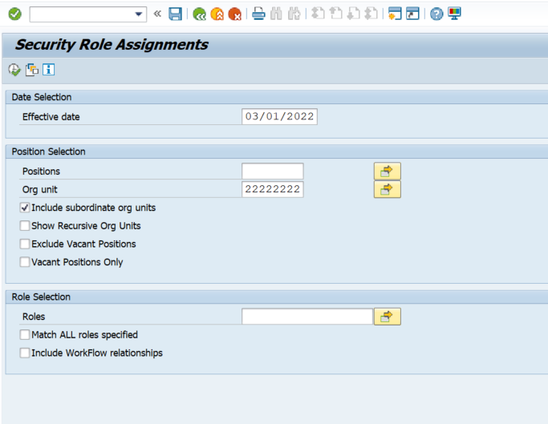
- Select the F9 Key OR Select Program and in the drop-down menu select (Execute in Background).

Security Role Assignment Report Tips:
TIP: You can use the Filter button to hide common roles or certain types of roles in the results. For example, you can hide BI roles by excluding roles that begin with “ZBI”.
TIP: You can view the results in Excel within SAP using the button, or you can export the results to a file for import into Excel or other applications using the button.
TIP: Using the button, you can change the column layout and save it as a layout variant.
TIP: The help button will bring up a pop-up button containing help information about the fields on the report.

Security Change Request Procedures with Roles Requiring Training

Security Change Request

- Agency Data Owner creates Security Request using SAP transaction ZSCRA or in the Integrated HR/Payroll System (SAP).
- Transaction links to LMS and the class is assigned to the employee’s transcript if training is required.
- The Integrated HR/Payroll System Security Request, generates an email to securityrequestsap@osc.nc.gov
Email includes:
Security Role Change Request Number (Subject Line)
Submitted by: XXXXXXXX Data Owners Name
Personnel Area: XXXX
For Employee: XXXXXXXX Employee Name
Example:
From: John Doe [mailto:John.Doe@ncdtst.gov]
Sent: Thursday, October 26, 2017 2:25 PM
To: SVC_OSC.securityrequestsap <securityrequestsap@osc.nc.gov>
Subject: Security Role Change Request - 11021716
Submitted by 01234567 John Smith Doe
Personnel Area: 2101
For Employee: 07654321 Janey Doe
E-mail correspondence to and from this address may be subject to the North Carolina Public Records Law and may be disclosed to third parties.

- BEST Call Center is responsible for processing the email, creating ticket, and assigning to Functional Security Support.
- If all required classes are completed, the Security Request status will be “I” for “In Progress”, this is confirmed by the “Security Request System”.
- If class is completed, the role(s) are assigned, the transaction status is completed, and the ticket is closed.
- If ALL classes are not completed, the Security Request status is entered as ‘Pending’ (for pending class completion) and the ticket is closed. *Non-training required roles will be assigned.
- Once the class is completed and in a “Pass” status, LMS feeds over to the Integrated HR/Payroll System the Security Request System processes this information, updating any “Pending” requests, to “In Progress”.

- The Integrated HR/Payroll System generates an email from BATCHSEC@OSC.NC.GOV and sends to securityrequestsap@osc.nc.gov.
Email includes:
Security Role Change Request Number (Subject Line)
Submitted by: XXXXXXXX Data Owners Name
Personnel Area: XXXX
For Employee: XXXXXXXX Employee Name
Example:
RE: Security Role Change Request - 11021716
-----Original Message-----
From: BATCHSEC [mailto:BATCHSEC@OSC.NC.GOV]
Sent: Friday, October 27, 2017 9:30 AM
To: SVC_OSC.securityrequestsap <securityrequestsap@osc.nc.gov>
Subject: Security Role Change Request - 11021716
Submitted by: 01234567 John Smith Doe
Personnel Area: 2101
For Employee: 07654321 Janey Doe
Please do not reply to this E-mail.
E-mail correspondence to and from this address may be subject to the North Carolina Public Records Law and may be disclosed to third parties.

- BEST Call Center is responsible for processing the email, creating a new HEAT ticket, and assigning to Functional Security Support Team.

- Functional Security Support team assigns the requested role(s).

- If all training is completed the ticket is closed.
  - If additional roles require training, the ticket will remain open until LMS is updated. Once LMS is updated additional HEAT tickets will be created.

Procedures for viewing the security change request:

- Access transaction code ZSCRD – Security Role Change Display.
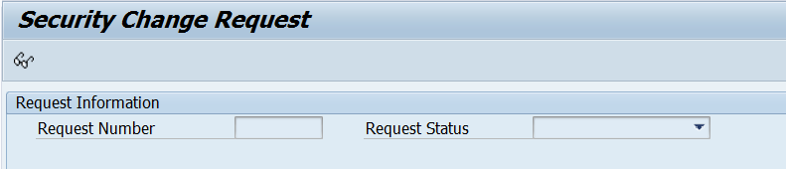
- Click View Request icon to activate the Request Number field.
- Key the request number which is found in the HEAT ticket.
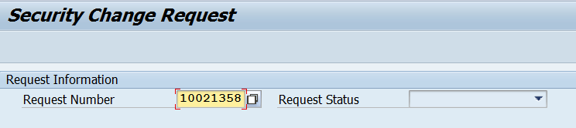
- Click or press Enter to display the request information.
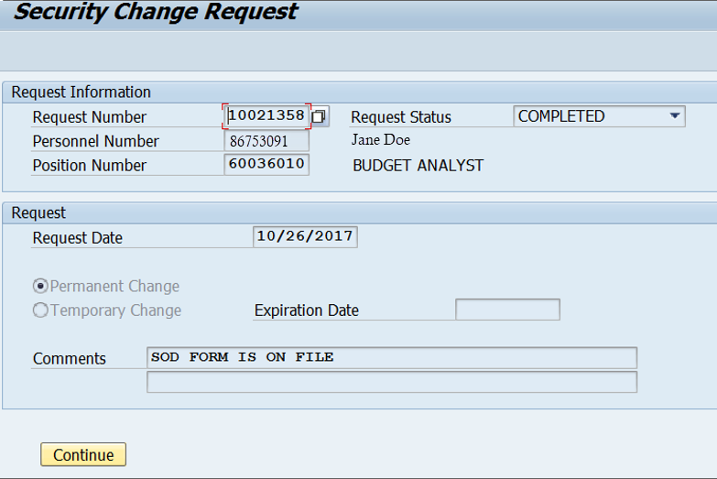
- Click Continue to display Employee Information and Role Information.
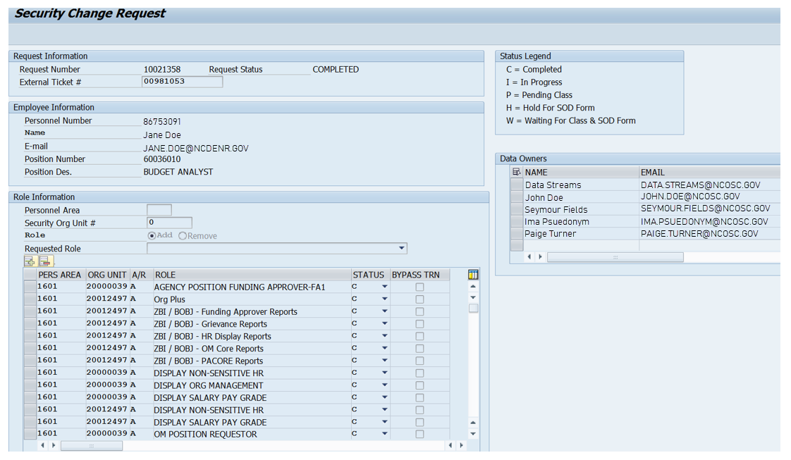

Copy Security Roles from Another Position
Business Process Procedure Overview:
Security Change Requests are created by Agency Administrators and Data Owners, and submitted by Data Owners to the BEST Shared Services Security Team for processing. In additional to adding roles manually to a request, users may copy the Security roles from an existing Position into a request.
This is especially useful when requesting similar access for multiple employees.
NOTE: Before beginning this process, know the Position number(s) whose roles you wish to copy. See the Security Role Assignment Report - ZSECROLE for more information about identifying the correct Position.

Creating a Security Request
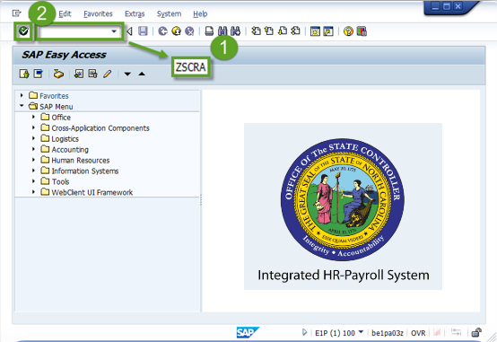
- From the SAP Easy Access Screen, type ZSCR or ZSCRA in the Command Field.
- Click Enter .
- Click Create .
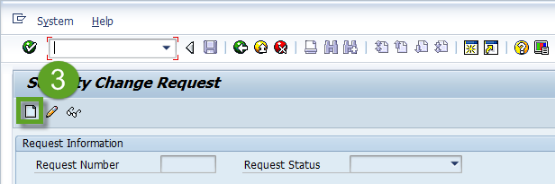
The Security Change Request screen will be displayed.
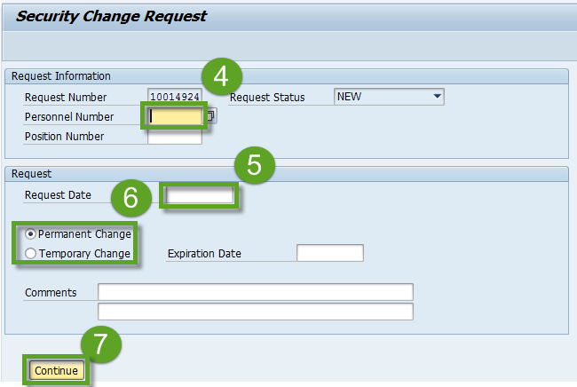
The system assigned Request Number will be displayed at the top of the page with the Request in NEW status.
- Enter the employee’s Personnel Number.
- Enter the Request Date.
- Select Permanent Change or Temporary (requires an Expiration Date).
- Click .
The Security Request Screen will be displayed.

**NOTE**
Add any Comments that would be helpful to the Security Administrator that processes the request.
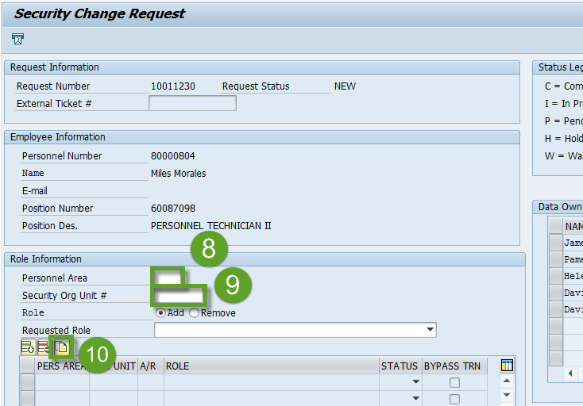
- Enter the Personnel Area.
- Enter the top Org Unit for which the employee will be granted Security.
- Click Copy Roles from Position .

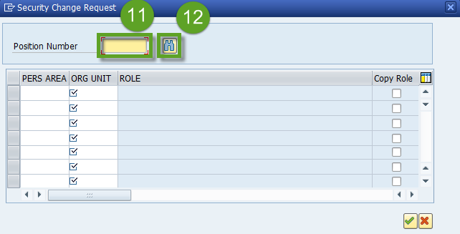
- Enter the Position number whose roles you wish to copy.
- Click Find .
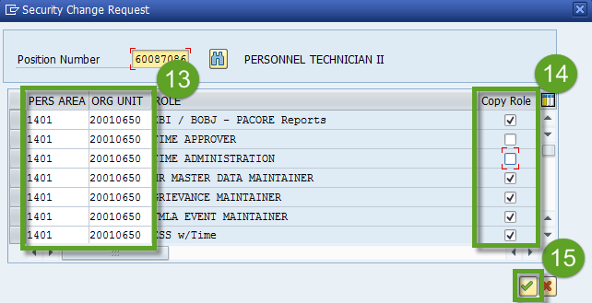
The Position’s current security roles will be displayed.
- Review the Personnel Area and Org Unit columns. Roles may be individually customized to change the Personnel Area and Top Security Org to which access is granted.
- Review the Copy Role column. If a role is unchecked it will not be added to the request.
- Click the Green Check .

If any of the Position’s roles require Training, or an SOD Risk Acceptance Form, the appropriate warning messages will be displayed in order.

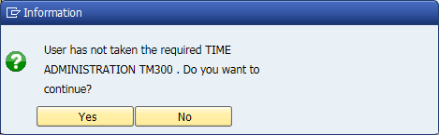

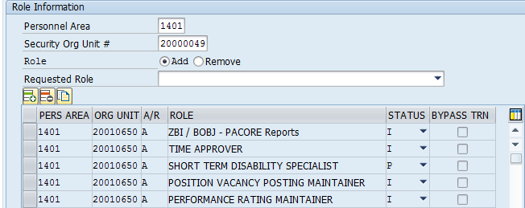
The Position’s Security Roles will then be added to the request.
NOTE: You may repeat this process if you wish to add roles from Multiple Positions.

Once all the desired Security Roles have been entered, and if you are a Data Owner (ZSCRA):
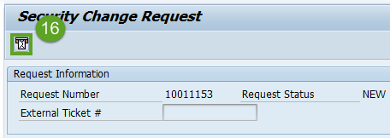
- (a) Click the Send Request button to submit the request to BEST Shared Services.
The Status of the Request will change to IN PROGRESS.
OR
If you are not a Data Owner (ZSCR):
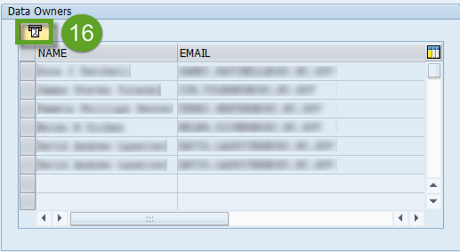
(b) Select the Data Owner you wish to email and click the Send Message button.
The system will then generate an email to the Data Owner, who can submit the request to BEST.

Managing Mass Change – Process:

- Agency Data Owner will need to contact Security Team
  - thurman.ross@osc.nc.gov
  - todd.wall@osc.nc.gov
  - daniel.rocker@osc.nc.gov
  - brad.johnson@osc.nc.gov

Agency Data Owner will need to provide:
  - Type of change
  - Number of Positions affected
  - Roles affected

- Security Team will review the request and may request additional information from agency.

- Once the Security Team reviews the request (3 days max), an email will be sent back to the requesting agency:
- Approving the request. (BSS, PMO will be copied on the email)
- Rejecting the request. (PMO team will be copied)
- Security team will forward the request to the PMO team for further analysis.

- If approved, the Data Owner will submit request via Heat Ticket Process.
44

Exceptions to Normal Role Assignment Process
- The following are exceptions:
  - BOBJ Reports
    - Requests can be made for only BOBJ Groups, not an individual report.
      - When assigned to a BOBJ Group, the employee has access to the highest structure (Org unit) that is currently assigned to the position
  - FI Report (ERP Report. Not BI Report)
    - Finance – Inquiry by Cost area
  - Cross Agency Verification Report
    - Not tied to a specific ERP Role
  - HR Role Exception Request (when role is “Pending Class”)
    - Temporary assignment of role(s) for 45 days
    - Must be a true business need!
    - Needs approval by Director of BEST Shared Services

Appendix

ERP Role Assign Matrix

BOBJ Report Description and Matrix

Key ERP Roles and Infotype Chart

Copy Of SOD Form

Process Flow

Link to HR Exception Request Form
Integrated HR-Payroll System Security Role Training Exception Request (Page 1 of 9) (office.com)

